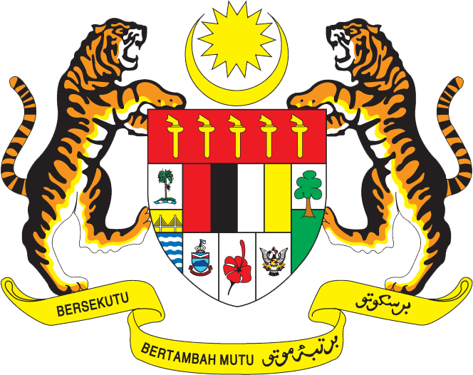

JKKP/DOSH
SAFETY ALERT
KEMALANGAN KREN MENARA AKIBAT KEGAGALAN PIN PENYAMBUNG COUNTER JIB PLATFORM

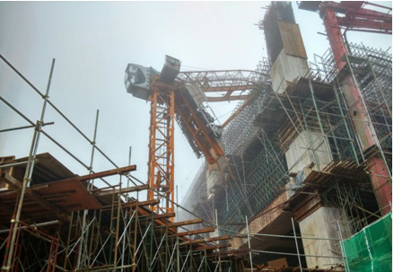

An oxygen cylinder exploded and caused death of 2 workers. The explosion also caused damage to the property. Oxy/fuel equipment that has been used is a combination of oxygen gas and LPG. The explosion occurred while one of the worker installing regulator on the oxygen cylinder. Portable oxy/fuel equipment that used in any tasks should be operated correctly and handled carefully. Further to this incident, it is recommended to follow these safety measures:
- Oxy/fuel equipment used in welding, cutting and similar processes must consist of components that designed for that particular purpose. Proper oxy/fuel equipment shown in Figure 2;
- Measures to prevent fire :
  - move the work piece to a safe location for carrying out hot work;
  - remove nearby combustible materials (such as flammable liquids, wood, paper, textiles, packaging or plastics);
  - protect nearby combustible materials that cannot be moved. Use suitable guards or covers such as metal sheeting, mineral fiber boards or fire-retardant blankets;
  - check that there are no combustible materials hidden behind walls or in partitions, particularly if the welding or cutting will go on for some time. Some wall panels contain flammable insulation materials, eg polystyrene;
  - use flame-resistant sheets or covers to prevent hot particles passing through openings in floors and walls (doorways, windows, cable runs, etc);
  - prevent flame, heat, sparks or hot spatter from landing on the hoses;
  - keep fire extinguishers nearby.
- Precautions to prevent gas leaks:
  - turn the gas supply off at the cylinder when the job is finished or before the cylinders are moved or transported;
  - isolate and purge or remove hoses and equipment from enclosed or poorly ventilated spaces when there is a break in work;
  - keep hoses away from sharp edges and abrasive surfaces or where vehicles can run over them;
  - do not allow hot metal or spatter to fall on hoses;
  - maintain all equipment and regularly check its condition.
- Regularly check all connections and equipment for faults and leaks. Equipment used in aggressive conditions such as demolition work or heavy engineering will normally need more frequent checks, eg weekly.
  - Use a proprietary leak detecting spray or solution suitable for use with oxy/fuel systems. Do not use soapy water or solutions containing grease or oils on oxygen systems.
  - Never look for gas leaks with a naked flame.
  - Immediately repair or replace leaking components.
- If a cylinder leaks when the valve is closed, move the cylinder outside and away from sources of ignition (naked flames, sparks, electric motors, etc). Prevent unauthorized access and notify the cylinder supplier immediately.
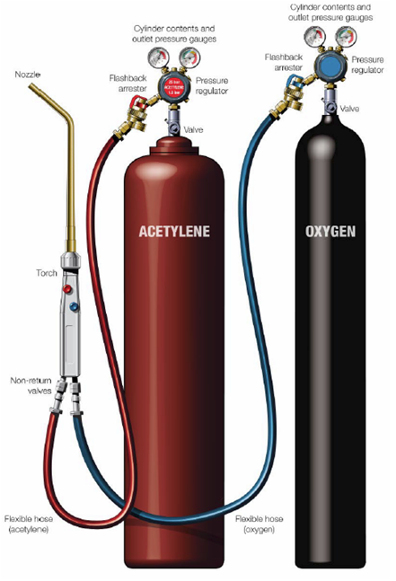
Figure 2: Proper 2 cylinders oxy/fuel equipment

References:
- Guidelines for gas cylinder safety, BOC, Australia
- Take care with oxygen , Fire and explosion hazard in the use of oxygen, HSE UK

